**MIGRATOry behaviour of Atlantic bluefin tuna entering the mediterranean**

Tom Carruthers[1], Antonio Di Natale[2], Matt Lauretta[3], Alfonso Pagá García2, Stasa Tensek2

*SUMMARY*

To do last

*KEYWORDS*

*Electronic tagging, migration, movement, bluefin*

# Introduction

Prior to electronic tagging experiments, historical information regarding bluefin tuna migration from the Atlantic Ocean into the Mediterranean Sea came from tuna trap fisheries which followed the seasonal reproductive migration of fish either entering the Mediterranean for spawning or those leaving after spawning (Avolio Di Paola, 1805; D’Amico, 1816; Pavesi, 1889; Parona, 1919; de Buen O., 1923, 1924a, 1924b; de Buen F., 1927a, 127b, 1931; Sella, 1929b; Rodríguez-Roda, 1964, 1965, 1966, 1983; Sarà, 1961, 1964, 1965, 1973, 1983, 1998; Scaccini, 1965; Mather *et al.*, 1995). The historical distribution of the tuna traps along most of the Mediterranean coast and were able to depict the sequence and seasonal timing of the migration. Additional evidence of Atlantic fish entering the Mediterranean was provided by examining the types of hooks found in bluefin tunas caught across the Mediterranean Sea (Tunisia, northern coast of Sicily, Turkey) (Sella, 1926a, 1926b, 1927, 1929a, 1930, 1931; Heldt, 1943; Genovese, 1959).

The modern fishery no longer captures this seasonal migratory behavior since very few tuna traps continue to operate in the Mediterranean (just three, all in the SW part of Sardinia, Italy) and most catches are now taken in a handful of days in the open sea in the most important spawning areas where the purse-seiners operate. While it is not clear whether the accounts arising from the historical trap are relevant to the migration of the modern population in any case these are accounts are largely overlooked.

Recent data collection programmes, such as those initiated and coordinated by the ICCAT GBYP (Di Natale *et al*., in press; Sissenwine and Pearce, in press) have provided new insights into the migratory behaviour of Atlantic bluefin tuna (*Thunnus thynnus*, L.). These include movement of individuals along the Atlantic coast of Morocco (Quilez-Badía *et al.*, 2013 a, 2013b; Di Natale and Tensek, 2015) and distant migrations to areas uninhabited since the first half of the twentieth century such as Norway and Greenland (Di Natale, 2012).

Electronic tagging experiments have provided invaluable information regarding the ecology, migration and stock composition of Atlantic bluefin tuna (Block *et al*. 2005, Lutcavage *et al*. 2012, Cermeno *et al*. 2015, Tensek *et al*., in press). Electronic tagging data are now one of the principal sources of data for identifying plausible hypotheses for stock mixing and movement that may be included in Management Strategy Evaluation (MSE) to identify robust management approaches (Butterworth and Punt, 1999). Additionally, these modelling programmes can be supported by the release and recovery information arising from conventional tagging.

The data obtained in recent years from the ICCAT GBYP electronic tagging activities were provided in real time to the scientific community by the GBYP reports, but in 2016 many sets of electronic tag data, deployed by other scientists, were made available thanks to the ICCAT GBYP data recovery activities or directly by some scientists who provided the data sets for the use of the Operating Model (OM) and the Management Strategy Evaluation (MSE) developed under the GBYP as requested by the ICCAT Commission and the SCRS (Anon., 2016, 2017).

These combined efforts resulted in a marked improvement of the data availability for the MSE in terms of bluefin tuna movements between areas and in the various parts of its distribution range, even if the data are sparse for the central-southern Atlantic (Di Natale 2011). Despite the availability of the raw data, a synthesis of new knowledge was yet to be prepared. Scientists of the 2017 SCRS bluefin tuna data preparatory meeting demanded an update in the current state of knowledge regarding migratory patterns for bluefin tuna tagged in the Atlantic Ocean that subsequently moved into the various areas of the Mediterranean Sea. The purpose of this report is to provide such a synthesis.

# Methods

In this descriptive study we focus only on those conventional and electronic tags that were released in the Atlantic Ocean and the Strait of Gibraltar that subsequently entered the Mediterranean Sea. To identify different migratory behaviours, the Mediterranean Sea was divided into five areas (**Figure 1**):

* Strait of Gibraltar; the narrow gateway to the Mediterranean Sea; the exploitation rate in this area can be relatively high and therefore tagged fish are often recaptured preventing further displacement into the various Mediterranean areas.
* Med Gate; the southern part of the western Mediterranean Sea, another key passage where all fish coming from the Atlantic will pass before reaching the main four spawning areas. Similarly to the Strait of Gibraltar numerous fishing activities are located in this area which can prevent further movement to other areas.
* Balearic; this area includes the true Balearic area, which is one of the four main spawning areas, but also the remaining parts of the Western Mediterranean Sea (the Catalan Sea, the Sardinian Sea, the Gulf of Lion, the Ligurian-Provençal basin and the western part of the Corsica Sea), which are important feeding areas.
* The Central Med; this very large area includes two of the most important spawning areas (the southern Tyrrhenian Sea and the central-southern Mediterranean Sea), but also other important areas for the migratory movements (the Strait of Sicily, the eastern Ionian Sea and the southern Ionian Sea) and other important areas, for juveniles distribution, for feeding and overwintering (the Gulf of Hammamet, the Gulf of Gabes, the eastern Sardinian Sea, the central and northern Tyrrhenian Sea, the Ligurian Sea, the Strait of Messina, the Adriatic Sea, the eastern Ionian Sea). The bulk of the Mediterranean catches of the bluefin tuna are historically coming from this large area.
* The East Med; this other large area includes the last of the main spawning areas (the Levantine Sea) and some areas where juveniles aggregate and where possibly some fish remains overwintering (the Aegean Sea, the Crete area, the Cyprus area and the Marmara Sea). The migratory fish which are able to reach this area are those who escaped from the fishing activities in all the other four areas, therefore surely a minority fraction.

The Black Sea was not included in these area definitions despite its historical significance, since bluefin tuna disappeared from this sea at the early beginning of the ‘80s. While there is evidence of fish returning to this area (Di Natale, 2015) no tags have been recovered thus far.

A large number of electronic tags have been released in the narrow area of the Strait of Gibraltar. In this descriptive analysis we separate these tags from those released into the Atlantic Ocean proper.

## Data

Data description from Matt

## Behaviours

We identified five distinct migratory behaviors for tagged fish entering the Mediterranean Sea, with movements to the:

* Balearic area
* Central Med area
* East Med area
* Central Med area via the Balearic area
* Balearic area via the Central Med

Electronic tags provide information on the last two intra-Mediterranean movement types that help to understand mixing in the Mediterranean Sea.

# Results

Of the 42 electronic tags entering the Mediterranean Sea from the Atlantic Ocean, the majority either moved to the Balearic area directly (43%) or moved there via the Central Med area (36%). Many fewer migrated to the Central Med (14%) and just one tag reached the East Med area (Table 1, Figure 2). Of the six electronic tags entering the Mediterranean Sea from the Strait of Gibraltar, most (5 fish) migrated to the Balearic area with just one ending in the Central Med (Table 1, Figure 3).

While Conventional tags ranked similarly with most ending in the Balearic area, followed by the Central Med and East Med areas, the fractions were somewhat different with 55% recaptured in the Balearic area, 38% in the Central Med and 6% in the East Med. This discrepancy may be explained by the dependence on exploitation for recapture of conventional tags and hence higher exploitation rates in Central Med and East Med areas. Interestingly, conventional tags released in the Strait of Gibraltar showed a different pattern with the majority recaptured in the Central Med area (67%).

< Comments on the heat map > Figure 4

< Comments on the origin of tags > Figures 5 and 6

# Discussion

< Discussion with respect to findings in the results >

At the beginning of the ICCAT GBYP it was decided to explore various hypotheses about a possible sub-stock structure of the eastern Atlantic Bluefin tuna within the Mediterranean Sea. A central recommendation of the SCRS and the GBYP Steering Committee was to carry out an intense multi-year set of analyses, based both on the micro-chemical and the genetic approaches to explore the various hypotheses regarding mixing and stock structure. All of these analyses which included samples from most Mediterranean areas and ages classes, supported the conclusion that there was no significant differentiating pattern in the samples (Di Natale *et al*., in press). After the discussion at the Tuna Future Symposium in Monterey (USA) in February 2016, it was decided to perform an additional experiment, by using in parallel (on the same samples) both the SNPs and the microsatellites for the genetic analyses. Even these analyses corroborated the lack of any genetic differentiation within the Mediterranean Sea (Arrizabalaga, 2017). This result counters the pre-conceptual hypotheses which were based mostly on historical descriptions of Bluefin tuna previously migrating to the Black Sea or on ideas such as the isolation of bluefin tuna spawners in the Balearic Sea.

Uncertainty remains over an unknown portion of so called ‘resident’ fish (hypothetically the majority) that stay for more than one year within the Mediterranean Sea (Di Natale *et al*., 2015) (it is still unknown whether bluefin tuna can remain for their entire life within the Mediterranean Sea). The resident portion of the stock may include young of the year, juveniles and adult fish of many size classes. Historically, the adult fraction was documented through the fisheries after the spawning seasons, and they were finally electronic tagged by ICCAT GBYP in 2016, confirming the overwintering in the Mediterranean Sea. These fish usually spawn in any of the Mediterranean spawning areas alongside those migrating from the Atlantic, generating mixing among areas of the Mediterranean Sea. It is also still unknown if the fraction of migratory fish (and the correspondent fraction of “resident” fish) varies every year and to which extent, but this yearly variability is likely to occur.

As concerns an hypothetical “spawning homing” behaviour, related to each of the spawning areas, there is no evidence to support this hypothesis. This is likely complicated by the ‘multi-spawner’ behavior of bluefin tuna in which multiple spawning events can occur over several weeks up to about one month and a half (Marino *et al*., 2005, Piccinetti *et al*., 2013). These may potentially occur in more than one area over the same spawning season, further increasing the likelihood of mixing within the Mediterranean Sea. This behavior may be central to the resilience of bluefin tuna which has persisted over the centuries to varying exploitation pressures within the Mediterranean Sea (Tinti *et al*. 2016).

# Acknowledgements

This work was carried out, in part, by TC under the provision of the ICCAT Atlantic Wide Research Programme for Bluefin Tuna (GBYP), funded by the European Union, several ICCAT CPCs, the ICCAT Secretariat and by other entities (see: http://www.iccat.int/GBYP/en/Budget.htm). The contents of this paper do not necessarily reflect the point of view of ICCAT or other funders and in no ways anticipate ICCAT future policy in this area.

# References

Anon. 2016, Aggregated electronic tagging data for use in operational modelling of Atlantic bluefin tuna. Available at: <https://github.com/ICCAT/abft-mse/blob/master/Data/Raw/PSAT/ALL_BFT_ElectronicTags_01122015.csv> [accessed Nov 2016]

Anon., 2017, Report of the 2017 ICCAT SCRS Bluefin Tuna Data Preparatory Meeting. Available at: <http://iccat.int/Documents/Meetings/Docs/2017_BFT_DATA_PREP_ENG.pdf>

Avolio Di Paola F., 1805, Delle Leggi Siciliane intorno alla Pesca. Reale Stamperia, Palermo : 1-239.

Arrizabalaga, H. 2017. Short term contract for biological studies ICCAT GBYP 09/2016 of the Atlantic-wide research programme on bluefin tuna. Available at: [http://www.iccat.int/GBYP /Documents/](http://www.iccat.int/GBYP%20/Documents/) BIOLOGICAL%20STUDIES/ PHASE%206/ Biological_Studies_AZTI.pdf

Block B. A., Teo S.L.H., Walli A., Boustany A., Stokesbury M.J.W., Farwell C.J., Weng K.C., Heidi D., Williams T.D., 2005, Electronic tagging and population structure of Atlantic bluefin tuna. Nature. 434: 1121-1127.

Butterworth D.S., Punt A.E., 1999, Experiences in the evaluation and implementation of management procedures. ICES J. Mar. Sci. 56, 985-998.

Cermeño P., Quilez-Badia G., Ospina-Alvarez A., Sainz-Trapaga S., Boustany A., Seitz A.C., Tudela S., Block B.A., 2015, Electronic tagging of Atlantic bluefin tuna (*Thunnus thynnus,* L.) reveals habitat use and behaviors in the Mediterranean Sea. PLoS ONE 10 (2): e0116638. doi: 0.1371/journal.pone.0116638.

D’Amico F.C., 1816, Osservazioni pratiche intorno alla pesca, corso e cammino de’ tonni. Società Tipografica, Messina: 1-164.

de Buen F., 1927a, Sobra la biología del atún, su pesca y conservación de sus carnes. Bol. Pescas, 12 (128) : 108-110.

de Buen F., 1927b, Notes et bibliographie sur la biologie du thon. Proc.-Verb. Cons. Explor. Mer., 44: 98-107.

de Buen F., 1931, El supuesto paso por el estrecho de Gibraltar del atún en su emigración genética. CIESM VI: 405-409.

de Buen O.,1923, Biología del atún. En: O. de Buen (dir.), Resultados de las campañas realizadas por acuerdos internacionales, Madrid, 1: 1-118.

de Buen O., 1924a, Las migraciones del atún en las costas Atlánticas del Sur España. Bol. Pescas, Madrid, 9 (92-93): 93-95.

de Buen O., 1924b, Les migrations du thon (*Orcynus thynnus*) sur les côtes atlantiques du Sud de l’Espagne. C.R. Acad. Sc., Paris, 178: 1104-1106.

Di Natale A., 2012, New data on the historical distribution of Bluefin tuna (*Thunnus thynnus*, L.) in the Arctic Ocean. Collect. Vol. Sci. Pap., ICCAT, 68 (1): 102-114.

Di Natale A., 2015, Revision of the historical and biological evidences about a population of Bluefin tuna (*Thunnus thynnus*, L.) in the eastern Mediterranean and in the Black Sea. Collect. Vol. Sci. pap., ICCAT, 71 (3): 1098-1124.

Di Natale A., Tensek S., 2016, ICCAT Atlantic-wide Research Programme for Bluefin tuna (GBYP) : Activity report for the last part of Phase 4 and the first part of Phase 5 (2014-2015). Collect. Vol. Sci. pap., ICCAT, 72 (6): 1477-1530.

Di Natale A., Mangano A., Piccinetti C., Ciavaglia E., Celona A., 2005, Bluefin tuna (*Thunnus thynnus* L.) line fisheries in the Italian seas. Old and recent data. Collect. Vol. Sci. pap., ICCAT, 58 (4): 1285-1295.

Di Natale A., Idrissi M., Justel Rubío A., 2013, The mistery of Bluefin tuna (*Thunnus thynnus*) presence in the South Atlantic in recent years. Collect. Vol. Sci. pap., ICCAT, 69 (2): 857-868.

Di Natale A., Tensek S., Pagá García A., 2016, Preliminary information about the ICCAT GBYP activities in Phase 5. Collect. Vol. Sci. pap., ICCAT, 72 (6): 1589-1613.

Di Natale A., Tensek S., Pagá García A., in press, ICCAT Atlantic-wide Research Programme for Bluefin Tuna (GBYP). Activity report for the last part of Phase 5 and the first part of Phase 6 (2015-2016). SCRS/2016/193.

Genovese S., 1959, Ami trovati in tonni (*Thunnus thynnus* L.) catturati in Sicilia e Calabria. Atti Soc.Pelor.Sc.Fis.Mat.Nat., V(4).

Heldt H., 1943, Etude sur le thon, la daurade et les muges. Histoires d’écailles et d’hameçons. Stat. Océan. Salammbô, Brochure 1 : 1-48.

Lutcavage M.E., Galuardi B., Lam T.C.H., 2012, Predicting potential Atlantic spawning grounds of western Atlantic bluefin tuna based on electronic tagging results, 2002-2011. Collect. Vol. Sci. Pap., ICCAT. 69 (2): 955-961.

Marino G., Candi G., Di Marco P., Longobardi A., Priori A., 2005, Supporto scientifico per la riproduzione controllata di grandi pelagici: *Seriola dumerilii* e *Thynnus thynnus*. ICRAM, Relazione finale VI Piano Triennale della Pesca e dell’Acquacoltura. Progetto di Ricerca 6C83.

Mather F.J.III, Mason J.M., Jones A.C., 1995, Historical document: Life History and Fisheries of Atlantic Bluefin Tuna. NOAA Tech. Mem., NMFS-SEFSC, 370: 1-165.

Parona C., 1919, Il Tonno e la sua pesca. R. Comit. Talass. Ital., Venezia, Mem. LXVIII: 1-259.

Pavesi P., 1889, L’industria del Tonno. Relazione alla Commissione Reale per le Tonnare. Min. Agric. Indust. Comm., Roma, Tip. Eredi Botta: 1-254.

Piccinetti C., Di Natale A., Arena P., 2013, Eastern Bluefin tuna (*Thunnus thynnus*, L.) reproduction and reproductive areas and seasons. Collect. Vol. Sci. pap., ICCAT, 69 (2): 891-912.

Quílez-Badia G., Cermeño P., Tudela S., Sainz Trápaga S., Graupera E., 2013, Spatial movements of bluefin tuna revealed by electronic tagging in the Mediterranean Sea and in Atlantic waters of Morocco in 2011. Collect. Vol. Sci. Pap., ICCAT, 69 (1): 435-453.

Quílez-Badia G., Cermeño P., Sainz Trápaga S., Tudela S., Di Natale A., Idrissi M. Abid N., 2013, 2012 ICCAT-GBYP pop-up tagging activity, in Larache (Morocco), Collect. Vol. Sci. Pap., ICCAT, 69 (2): 869-877.

Rodriguez-Roda J., 1964, Movimientos migratorios del atun, *Thunnus thynnus* (L.), deducidos por nuestras propias “marcaciones” en aguas españolas. Publicaciones tecnicas de la junta de estudios de pesca, Direccion General de Pesca Maritima, Madrid, 3: 279-304.

Rodriguez-Roda J., 1965, Sobre las fluctuaciones en la produccion de atunes de las almadrabas sudatlanticas, Publicaciones Tecnicas de la Junta de Estudios de Pesca, Madrid. 4: 205-209.

Rodriguez-Roda J., 1966, El atún, *Thunnus thynnus* (L.), de la costa sud-atlántica de España en la campaña almadrabera del año 1964 y consideraciones sobre las fluctuaciones periódicas. Investigación Pesqueras, Barcelona, 30: 9-35.

Rodríguez-Roda, J., 1983. Lo que sabemos sobre la biología del atún. In: Ibérica, actualidad científica, número, 240: 23-26.

Sarà R., 1961, Observations systématiques sur la presence du thon dans les madragues siciliennes. Proc. Gen. Fish. Coun. Médit., 6: 41-61.

Sarà R., 1964, Données, observations et commentaires sur la présence, le comportement, les caractéristiques et les migrations des thons en Méditerranée. Proc. Gen. Fish. Coun. Medit. 7, 37: 371-388.

Sarà R., 1965, Sur la présence du thon rouge (*Thunnus thynnus*) le long des côtes d’Italie. Proc. Gen. Fish. Coun. Médit., 8:73-77.

Sarà R., 1973, Sulla biologia dei tonni (*Thunnus thynnus* L.). Modelli di migrazione ed osservazione sui meccanismi di migrazione e di comportamento. Boll. Pesca Piscic. Idrobiol., 28: 217-243.

Sarà R., 1983, Tonni e Tonnare, Una Civiltà, una Cultura. Libera Università di Trapani Ed., Trapani: 1-128.

Sarà R., 1998, Dal mito all’aliscafo. Storie di Tonni e Tonnare. Banca Aegusea Ed., Favignana-Palermo: 1-271.

Scaccini A., 1965, Biologia e pesca dei tonni nei mari italiani. Ministero Marina Mercantile, Mem. 12. 101 p.

Sella M., 1926a, Altri fatti sopra la migrazione dei tonni accertati per mezzo degli ami. Rend. Reale Accad. Dei Lincei, Roma, IV, ser.6, 2 sem.(5-6): 223-227.

Sella M., 1926b, Le migrazioni dei tonni studiate per mezzo degli ami. Atti R. Accad. Dei Lincei, Roma, III, ser.6, 1 sem.(II): 696-700.

Sella M., 1927, Les migrations des thons étudiées par le moyen des hameçons. Bull. Trav. Pub. Stat. Aquicul. Pêche, Castiglione, 2 : 101-136.

Sella M., 1929a, Migrazioni ed habitat del tonno (*Thunnus thynnus* L.) studiati col metodo degli ami, con osservazioni sull’accrescimento, sul regime delle tonnare, ecc. Mem. R. Com. Talass. Ital., 16: 3-24.

Sella M., 1929b, Biologia e pesca del tonno (*Thunnus thynnus* L.). Atti Conv. Biol. Mar. Appl. Pesca, Messina, Giugno 1928: 3-32.

Sella M., 1930, Distribution and migrations of the tuna (*Thunnus thynnus* L.) studied by the method of hooks, and other observations. Internationale Revue des gesamenten Hydrobiologie und Hydrographie, 24 (5/6): 445-466.

Sella M., 1931, The tuna (*Thunnus thynnus* L.) of the Western Atlantic. An appeal to fishermen for the collection of hooks found in tuna fish. Internationale Revue des gesamenten Hydrobiologie und Hydrographie, 25 (1/2): 46-47.

Sissenwine M., Pearce J., in press, Second review of the ICCAT Atlantic-wide Research Programme on Bluefin tuna. ICCAT GBYP Phase 6, 2016). SCRS/2016/192.

Tensek S., Di Natale A., Pagá García A., in press, ICCAT GBYP PSAT tagging: the first five years. SCRS/2016/138.

Tinti, F., Puncher, G.N., Cariani, A. 2016. Historical generic samples collected in old times in the Eastern Mediterranean Sea, in the Marmara Sea or in the Black Sea, including the genetic analysis of these samples (GBYP Project 04/2016). Available at: <http://www.iccat.int/> GBYP/ Documents/ DATA%20RECOVERY/ PHASE%205/HISTORICAL_GENETIC_REPORT_PHASE5_UNIBO.pdf

## Table 1. The frequency of movement types of electronic and conventional tags originating from the Atlantic and Strait of Gibraltar. Note that multistage movement types (e.g. ‘To central Med via Balearic’) cannot be determined from conventional tag release and recapture information.



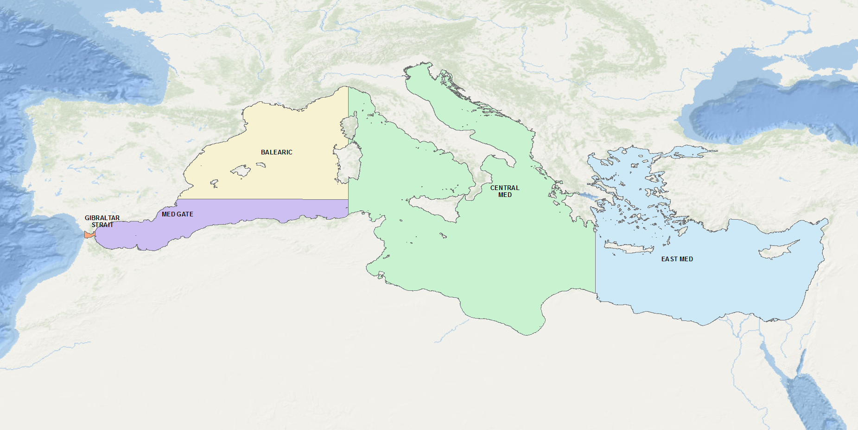

**Figure 1.**  Areas defined for studying the distribution of tags for Bluefin tunas tagged in the Atlantic which popped-off or were recovered in the various parts of the Mediterranean Sea.

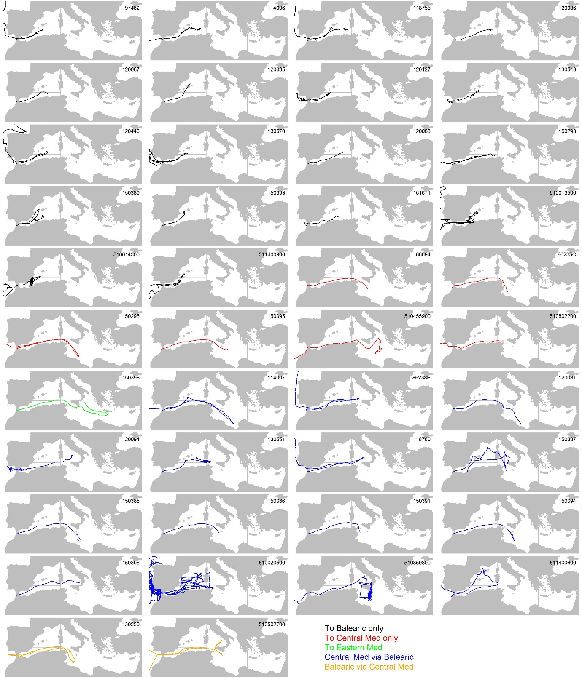

**Figure 2.** Electronic tag tracks for all tags entering the Mediterranean originating in the Atlantic organized by movement type.

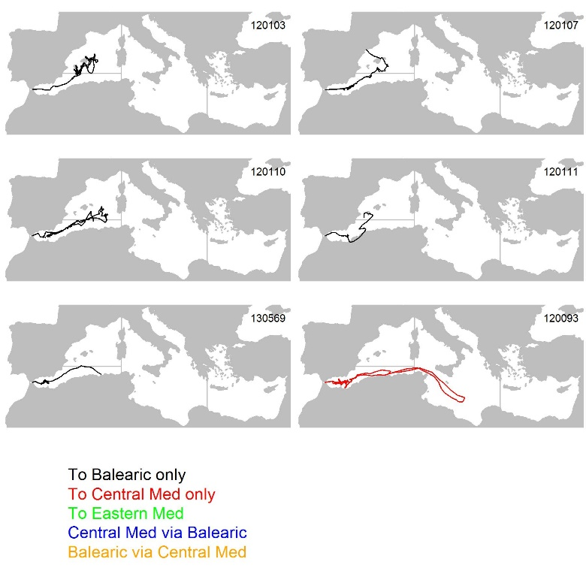

**Figure 3.** Electronic tag tracks for all tags entering the Mediterranean originating from the Strait of Gibraltar organized by movement type.

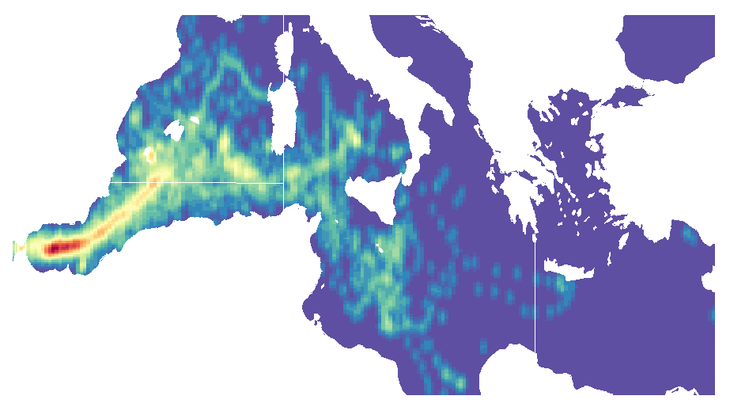

**Figure 4**. Heat map of daily electronic tag density.

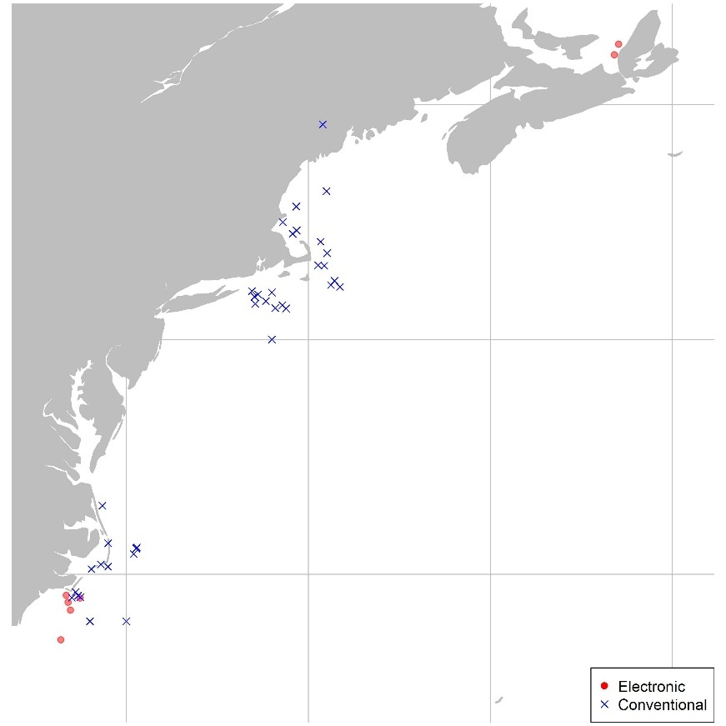

Figure 5. Origin (western areas) of electronic and conventional tags entering the Mediterranean

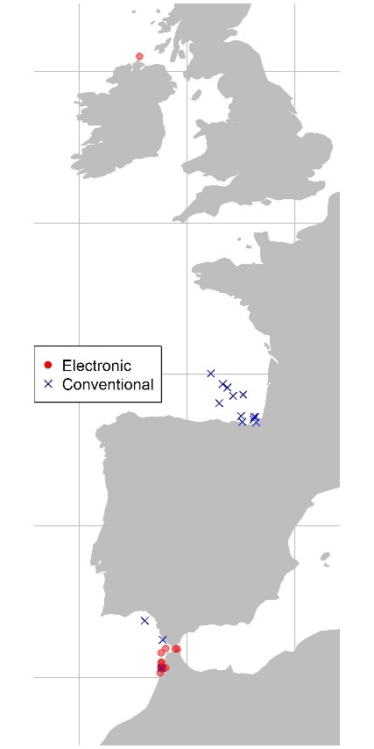

Figure 6. Origin (Eastern areas) of electronic and conventional tags entering the Mediterranean

1. IOF, 2202 Main Mall, University of British Columbia, Vancouver, B.C., Canada, V6T 1Z4. [t.carruthers@oceans.ubc.ca](mailto:t.carruthers@oceans.ubc.ca)
2. GBYP, International Commission for the Conservation of Atlantic Tunas, ICCAT, Calle Corazón de María, 8, 28002 Madrid, Spain. [antonio.dinatale@iccat.int](mailto:antonio.dinatale@iccat.int); [alfonso.paga@iccat.int](mailto:alfonso.paga@iccat.int) ; [stasa.tensek@iccat.int](mailto:stasa.tensek@iccat.int)
3. U.S. National Marine Fisheries Service, Southeast Fisheries Center, Sustainable Fisheries Division, 75 Virginia Beach Drive, Miami, FL, 33149-1099, USA. E-mail: [matthew.lauretta@noaa.gov](mailto:matthew.lauretta@noaa.gov)